Threepio Salad
(Inspired by C-3PO)
A DOLE® “Unite for a Healthy Galaxy” Recipe
Prep: 15 min. Makes: 2 Servings
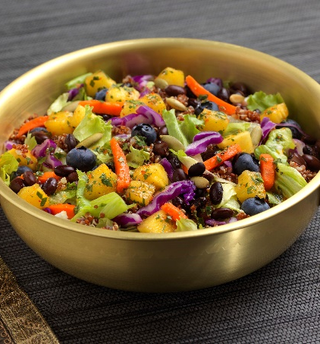
Ingredients:
- 2 tablespoons fresh lime juice
- 2 tablespoons extra-virgin olive oil
- 1 tablespoon chopped cilantro
- 1/2 to 1 teaspoon of chili powder
- 1/2 teaspoon freshly ground black pepper
- 1/2 cup DOLE® Pineapple, cut into small cubes
- 1/2 cup cooked quinoa
- 2 cups DOLE® Classic Iceberg Salad
- 1/2 cup reduced-sodium black beans,
rinsed and drained
- 1/2 cup DOLE® Blueberries
- 1 tablespoon pumpkin seeds

Directions:
Combine lime juice, oil, cilantro, chili powder and black pepper in a medium bowl. Whisk to blend. Stir in pineapple. Divide and layer in order: dressing, pineapple, quinoa, salad, black beans and blueberries between two 1-quart resealable containers. Sprinkle each salad with pumpkin seeds. Cover and refrigerate. Let containers sit at room temperature for at least 20 minutes before serving. Shake container before eating to distribute ingredients.
NOTE: Salad will keep, covered and refrigerated, for one day.

