Gorilla Walker Greens
(Inspired by Gorilla Walker)
A DOLE® “Unite for a Healthy Galaxy” Recipe
Prep: 15 min. Chill: 30 min. Makes: 4 servings
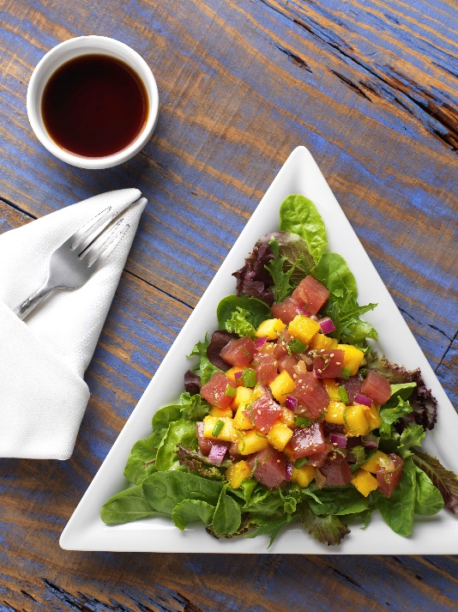
Ingredients:
- 2 tablespoons DOLE® Red Onion, finely diced
- 1/4 cup DOLE® Green Onions, chopped
- 1/4 cup low sodium soy sauce
- 1 teaspoon honey
- 1 tablespoon low sodium sesame oil
- Zest of 1 lime
- 1 tablespoon lime juice
- 1 tablespoon pickled ginger, minced
- 12 ounces sushi-grade yellowfin tuna, cut into bite
size cubes
- 2 cups DOLE® Pineapple, peeled and cut into
small dice
- 1 pkg. (5 oz.) DOLE® 50/50 Blend or Spring Mix Salad
- 1 teaspoon sesame seeds

Directions: Combine red onion, green onion, soy sauce, honey, sesame oil, lime zest, lime juice, and pickled ginger in a large bowl. Add tuna and pineapple, and carefully fold into the marinade. Cover with plastic wrap and chill 30 minutes. Serve on top of salad blend. Top with sesame seeds.

